**Apple to apple Comparison – Method 1**

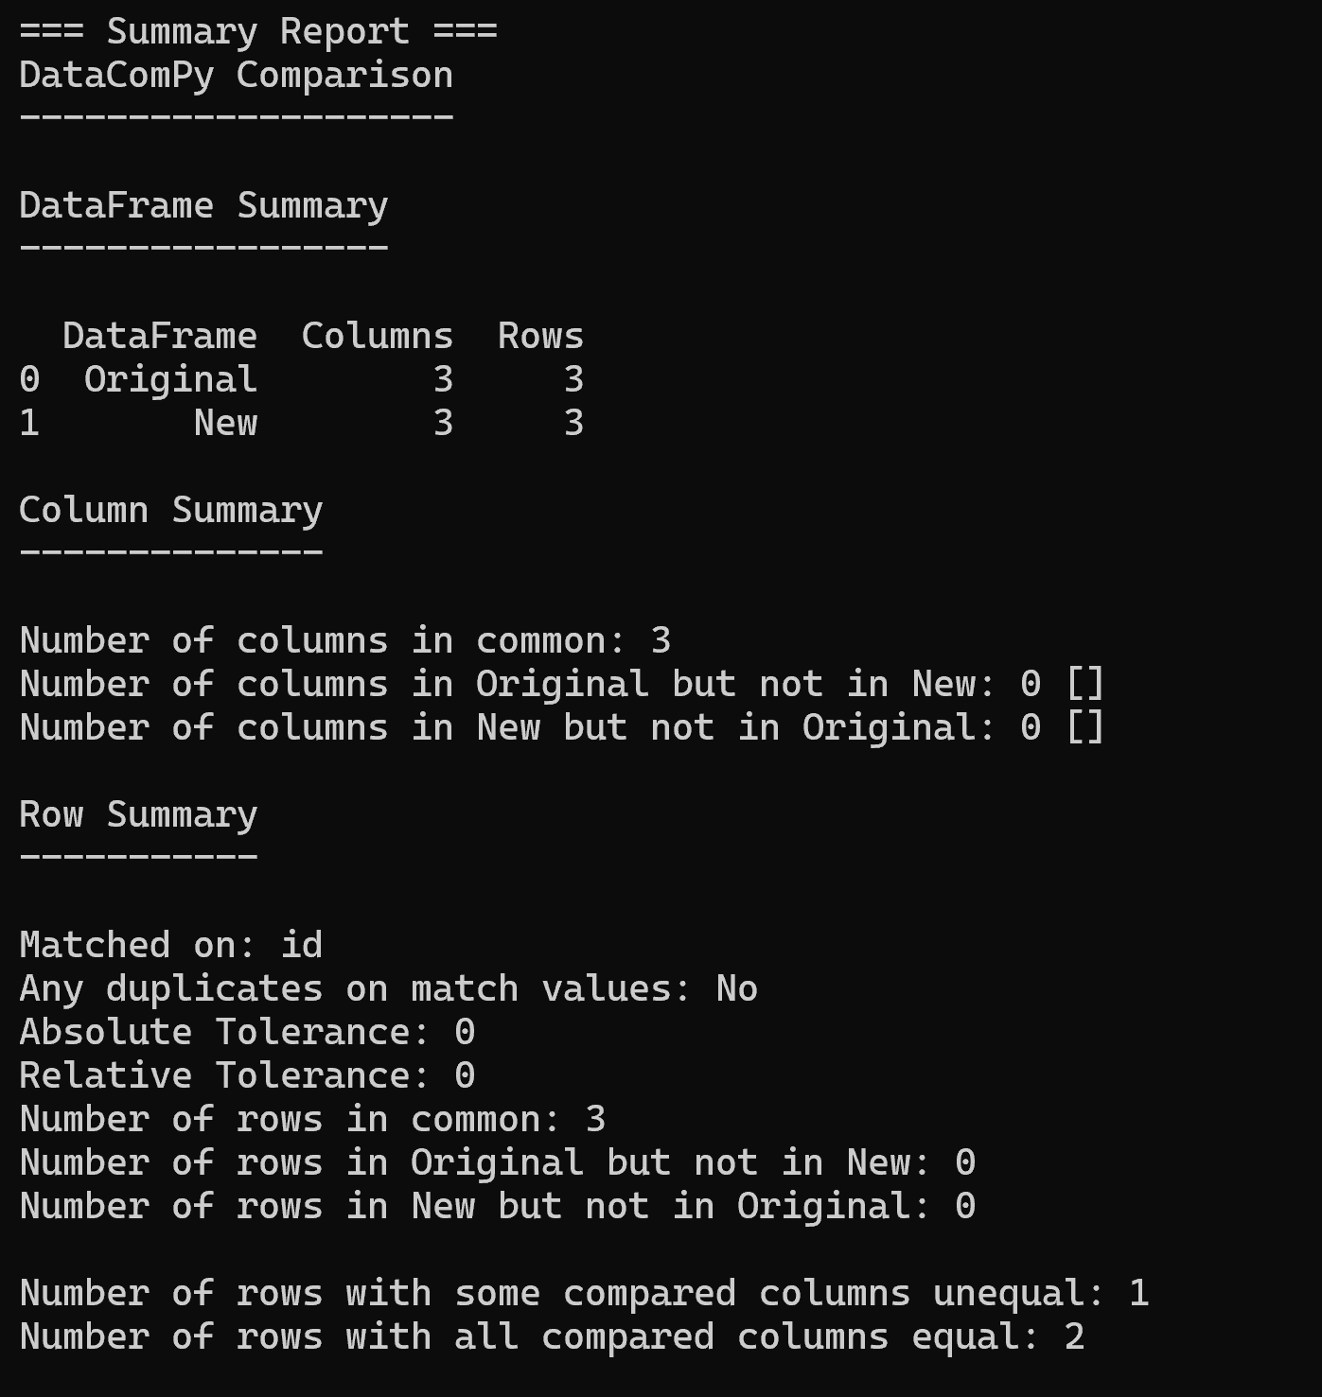

**Apple to apple Comparison – Method 2**

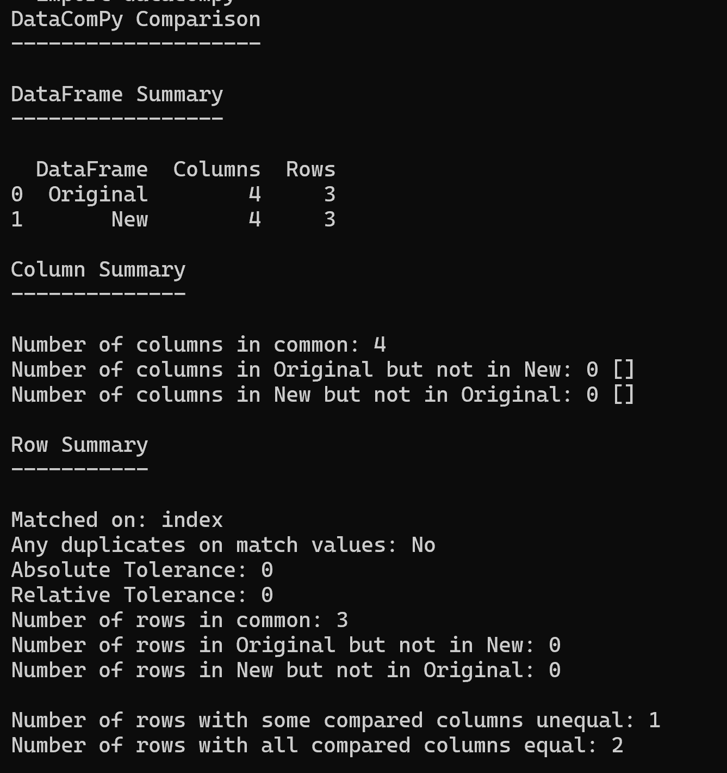

The same file can be uploaded to Jira as part of customization.